Book or Article Title. | Suitable age or year group. | Why it is recommended.
  The Healthy Lunchbox by F Beckett | All ages for supported shared reading. | Offers suggestions for tasty lunchbox options. Ideas about what children from other countries eat. Ideas for fussy eaters.
  Website:  www.foodafactofliffe.org.uk | All ages (3-16). Includes interactive games, quizzes and articles. | Huge amount or resources in different formats; where food is sourced, it’s benefits and skills needed to cook, as well as recipes.
    https://www.nhs.uk/healthier-families/  https://www.nhs.uk/healthier-families/recipes/ | All ages for supported shared reading. | NHS guide to a healthy lifestyle for children and families. Better Health, child friendly recipes.
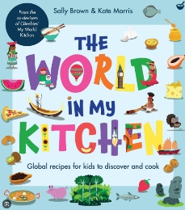  The world in my kitchen by Sally Brown and Kate Morris | All ages | Recipes from around the world, which are nicely illustrated with lists of ingredients, equipment and facts about Asia, Africa, North America, Australasia, Europe and South America.

