Book or Article Title. | Suitable age or year group. | Why it is recommended.
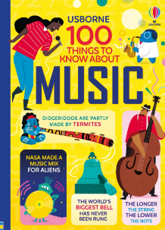  100 Things to know about music. | Key Stage 3 | This book is full of interesting facts, which are presented in an engaging and colourful format.
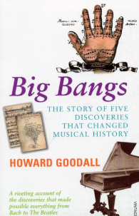  Big Bangs by Howard Goodall | All year Groups. | This book provides a history of Western Music
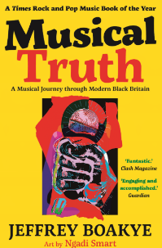  Musical Truth by Jeffery Boakye | Key Stage 4 | A different narrative and perspective on key moments in the history of music across the British Empire.
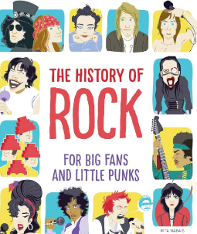  History of Rock for Big Fans and Little Punks. | All year groups | Information about some of the greatest songs and artists and notes about how to become a rock star.

