Book or Article Title. | Suitable age or year group. | Why it is recommended.
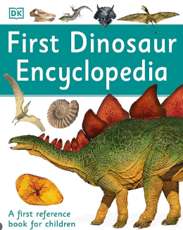  First Dinosaur Encyclopaedia | Years 7, 8 &9 | This book is full of maths facts. For example dinosaur heights, size of dinosaur eggs etc. These facts show applied Maths in a popular topic.
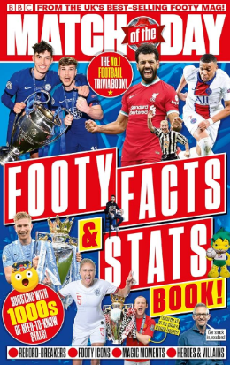  Match of the day: Footy Facts and stats | All year groups | Football statistics. Using Maths, even when talking about sport.
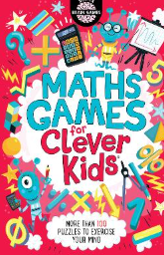  Maths Games for Clever Kids by Gareth Moore | All year groups | From times tables and shape-based search scenes to mental arithmetic conundrums and pictorial puzzles.
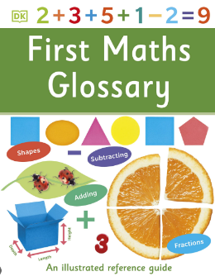  First Maths Glossary | Years 7, 8 &9. | Key Maths vocabulary supported by clear accessible diagrams.

