Book or Article Title. | Suitable age or year group. | Why it is recommended.
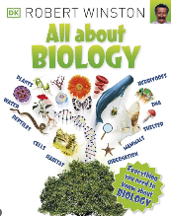  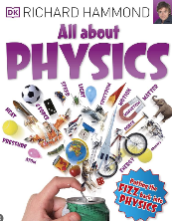  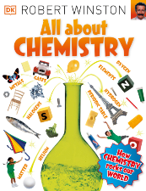  All About Chemistry and Biology by Robert Winston. All About Physics by Richard Hammond | Reading ages 8-10 years. | A deeper look in to the three areas of science.
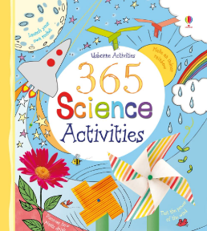  Usborne 365 Science Activities | Reading ages of 6ears + | Active, cross generational activities that can engage everyone in the family or to work on individually.
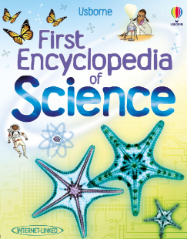  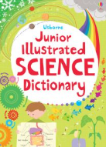  Usborne Junior Illustrated Science Dictionary and First Encyclopaedia of Science. | Rading age 8years + | An well illustrated and easy to use dictionary.

