
Suggested extended reading list for ICT.
Book or Article Title. | Suitable age or year group. | Why it is recommended.
Online article 10 famous women who have had an influence on the world of computers.  https://www.womenintech.co.uk/10-famous-women-technology-changed-world/ | All | Women in technology are not as well publicised as men and this highlights the very fact that women are just as great!
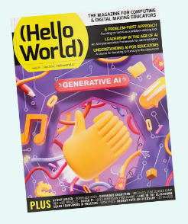  Hello World magazine, published by the Raspberry Pi Foundation | KS4 | A free online magazine that breaks down some complex issues into easy to understand bites and is worth reading. It is great for example looking at AI especially when it was new and gives some good ideas and explanations. It helps keeps us up to date with technological advances.
https://www.seeability.org/news/seeability-creates-new-easy-read-guides-staying-safe-online   | KS3 | This is a good read for year 7/8’s to reiterate some of what has been taught regarding online safety. Pictures and text that makes it accessible to all abilities.

