Book or Article Title. | Suitable age or year group. | Why it is recommended.
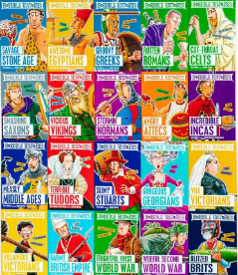  Horrible Histories | Years 7 - 9 | This is a series of books that link to all different parts of history and link in to the television series. Students will love reading the unpleasant and gory bits of history.
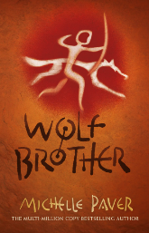  Wolf Brother by Michelle Paver | Reading age 9+  Suitable for year 7 | A series f books about a prehistoric boy, Torak. Provides a fictional account of life in the stone age.
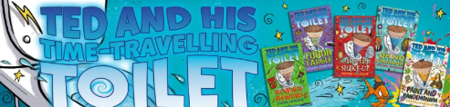  Ted and his time Travelling Toilet by Steven Vinacour | Reading age 7+  Suitable for years 7 -9 | A fun series of books that cover many of the people learnt about in the lessons, people such as Mary Anning (Yr7), David Attenborough (yrs7 -9), Greta Thunberg (Yr8).
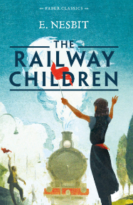  The Railway Children | Year 9 | The story of a Family who find themselves in a new home after the arrest of their Father. The three children, Roberta (known as Bobbie), Phyllis and Peter, find amusement in watching the trains on the nearby railway line and waving to the passengers.
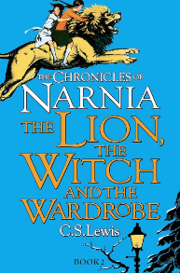  The Lion the Witch and the Wardrobe. |  | A popular story of three children who are evacuated during World War Two, to their Uncles big Country House. What do they find in the Wardrobe?

