Book or Article Title. | Suitable age or year group. | Why it is recommended.
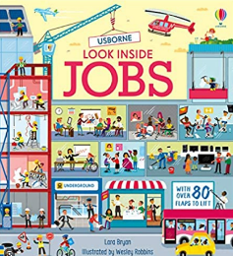  Look Inside Jobs | KS3 | A very visual interactive book that explores the different types of jobs available in different locations and situations.
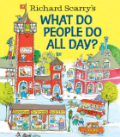  Richard Scarry’s What Do People Do All Day?  by Richard Scarry | Year 7 | Richard Scarry’s Busytown is always a fun place to visit, and this classic picture book takes readers through the various jobs that keep Busytown humming. Readers will meet firefighters and farmers, doctors and construction workers, teachers and bus drivers, all illustrated with Richard Scarry’s vibrantly detailed style.
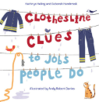  Clothesline Clues to Jobs People Do by Kath | Year 7 | This colourful picture book encourages critical thinking and is a great way to engage your child during a read-aloud session. Featuring clothes hanging on a clothesline, each outfit is tied to a specific career — like a chef’s apron and a toque or an artist’s smock and brushes — and the following page details each exciting job.
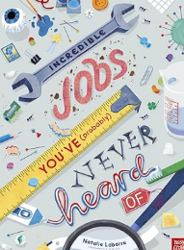  Incredible Jobs You’ve (Probably) Never Heard Of | KS4 | Do you know what you want to do when you grow up? Why not work as a babysitter . . . for sloths? Or become a farmer . . . of corpses? You might even grow up to be someone who gets paid to actually sleep on the job! From taste testers to dinosaur dusters, there are all kinds of incredible jobs that you've probably never heard of . . . and one of them might be just right for you

