Book Title | Recommended year group or reading age | Reason for the suggestion
Boukili : Free illustrated children’s books in French  Boukili.ca/en/ | Year 7 and 8  Niveau 1, 2, 3, 4 | Simple vocabulary with common themes from the MFL Curriculum such as ‘Les Jours de la Semaine’.  Free e-book in app once log in created as a parent.
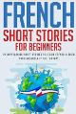  French Short Stories for Beginners, Lingo Mastery | Year 8 and 9 | Twenty short stories with themes seen in lessons as well as summaries in French and in English.
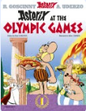  Astérix aux Jeux Olympiques,  René Goscinny | Year 9 and 10 | Comic book with straightforward vocabulary seen in Year 7, 8 and 9. Great fun to read!
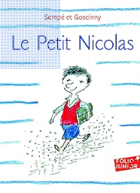  Le Petit Nicolas,  Sempé-Goscinny | Year 10-11 | More independent reading with simple vocabulary about school adventures and friendships.

Suggested extended reading list for MfL

