Book or Article Title. | Suitable age or year group. | Why it is recommended.
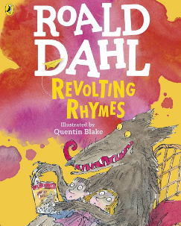  Revolting Rhymes by Roald Dahl | Years 7 and 8 | This book of short reads is great for getting the imagination going. It is often used as inspiration for fairy tales and panto plots.
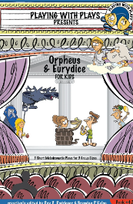  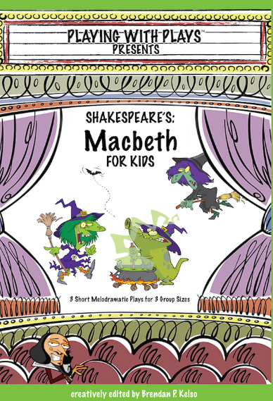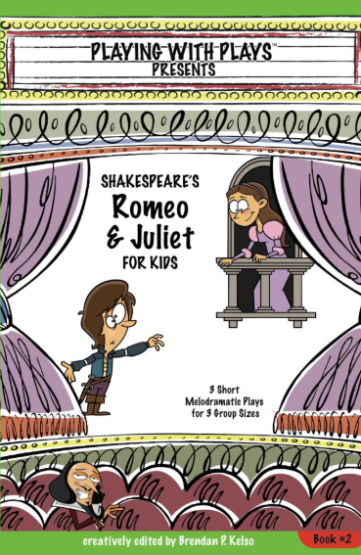  Play with Plays Shakespeare | Yrs, 7, 8 &9. | A series of books, each explaining a different Shakespear lay.
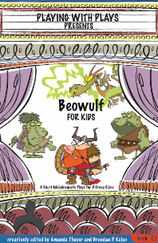  Play with Plays, Beowuit. | Years 7 & 8 | This book is good when studying green theatre.
  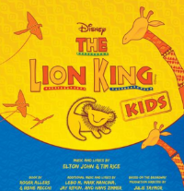  Disney Kids Scripts | Years 7 and 8 | A set of scripts that are referred to in lessons when looking at musical and scripts.

